2016年11月5日北京地区成人学位英语考试真题
- Reading Comprehension
Passage 1
If Dakota Access Pipeline (输油管道) completed, it will carry nearly half a million barrels of oil across four states every day. Energy Transfer Partners (ETP), a Texas-based company behind the $3. 8 billion project hopes to finish construction this year. But the Standing Rock Sioux, an American Indian tribe (部落), is determined to stop the 1,172-mile pipeline from being built. (76) Both sides show no signs of backing down.
The Dakota Access Pipeline was announced in 2014. A section of it will run near the Standing Rock Sioux reservation. A reservation is an area of land set aside for American Indians. The tribe says the construction threatens to destroy historical areas and ancient burial sites. They also say the pipeline could pollute their main water source, the Missouri River. In April, the Standing Rock Sioux began a protest against the project. They camped at the construction site. Since then, thousands of people, including people from other American Indian tribes, have traveled to the side to join the protest.
ETP says that the pipeline will have built-in measures to protect against oil leaks. Workers will also monitor it remotely, and will be able to close valves (阀) within three minutes if leaks are detected.
American Indians have been staging a nonviolent protest for months. The protest took a turn last week when police were called to keep the peace between protesters and armed security guards hired by the company.
(77) Twenty-eight people have been arrested since then and charged with interfering with the pipeline construction.

1. Which of the following is the main idea of the passage?
A. The Dakota Access Pipeline will create more markets for oil and gas.
B. The Dakota Access Pipeline will create many job opportunities.
C. American Indians oppose the construction of an oil pipeline.
D. American Indians fight for equal voting rights.
2. ETP hopes to finish this project in _____.
A. 2016 B. 2017 C. 2018 D. 2019
3. Why do American Indians protect against the construction of this pipeline?
A. Because it will cost up to $3.8 billion.
B. Because it threatens the region’s water supply.
C. Because it will make many people lose their jobs.
D. Because it will force many people to leave their homes.
4. According to the passage, the workers can _____ in case of pipeline leaks.
A. report to the local government B. ask people to leave the leak affected areas
C. call 911 D. close valves
5. According to the passage, which of the following statements is NOT TRUE?
A. This pipeline will cross four states.
B. This pipeline is 1,172 miles long.
C. All the protesters are from the Standing Rock Sioux.
D. Neither sides of the dispute is willing to compromise.

Passage 2
As the National Park Service celebrates its 100th anniversary(周年纪念), Preside Barack Obama has announced the establishment of one new national monument and the expansion(扩大)of another. In Maine, more than 87,500 acres of forest will become government-protected parkland for the first time. In Hawaii, a national monument created by President George W. Bush in 2006 expand to about 582,578 square miles, four times its current size.
Obama has now created or enlarged 25 national monuments during his presidency. As a result, his administration says, Obama has protected more of the nation’s land than any other president has. But some residents and officials, in both Maine and Hawaii object to the plans. (78) They say their local economies depend on the use of these areas.
In establishing this monument Obama took the side of conservationists (自然资源保护者) who want laws to protect wild lands. Creating a national park usually requires the approval of Congress. But a 1906 federal law allows the president to establish national monuments on his own.
The land’s new status as a monument means that mining and drilling operations are forbidden there. (79) It may also severely limit activities such as logging, road-building, and hunting. Some of Maine’s politicians who want to protect the state’s logging industries say Obama should not have acted alone. They say Washington should not tell the states how to use their land, especially when people’s jobs are at stake. Maine politicians Susan Collins say the president should have listened to Maine lawmakers and residents, as well as to the U.S Congress before making his decision.
However, those who support the president’s decision say the establishment of the new monument will lead to new jobs through tourism.
6. Which of the following is the best title for the passage?
A. Creating New Jobs B. Protecting Wild Animals
C. Stimulating Local Economies D. Creating New National Monuments
7. Obama has established or enlarged ____ national monuments during his two terms.
A. 19 B. 20 C. 26 D. 30
8. In national monuments, ____ is forbidden.
A. logging B. hunting C. minding D. road-building
9. The phrase at stake in Paragraph 4 is closest in meaning to _____.
A. in return B. in danger C. at present D. by chance
10. According to the passage, which of the following statements is NOT TRUE?
A. The national monument in Hawaii was created by President Bush.
B. There is no objection to President Obama’s decision.
C. President Obama made this decision on his own.
D. The establishment of the new monument will lead to new jobs.

Passage 3
Toronto’s third City Hall, now known as Old City Hall, was designed by Edward James Lennox and declared open on Sept. 18, 1899.
Created to provide more space for city officials, it turned out to be the largest building in the city and the largest city building in North America at the time.
Lennox took three years to design the City Hall and it took 11 years to build it. Contemporaries believe that the odd carving (雕刻) above Queen Street entrance were actually caricatures(漫画) of councilors at the time.
Lennox even included himself in the caricatures, on the west side of the central arch（拱门）and left a strange signature in the stonework of the link portions of the building.
The third City Hall was originally used as councilors’ offices and legal offices, but it is used only as a courthouse today.
When the fourth City Hall (the one we know today) was declared open in 1965, Old City Hall was threatened to be pulled down. It was saved by a group of people called the “Friends of Old City.”
The clock tower stands parallel with the middle of Bay Street, rather than with the centre of the building. The bells in the tower were not installed until the building opened. Old City Hall was declared a historical site in 1989.
The entire structure close more than $2.5 million to build at the time. This is equal to $53 million today.

11. Toronto’s third City Hall came into use in _____.
A. the 18th century B. the 19th century C. the 20th century D. the 21st century
12. Old City Hall was constructed in ____ years.
A. 3 B. 7 C. 9 D. 11
13. The third City Hall is now used as a _____.
A. middle school B. hospital C. cinema D. courthouse
14. From the passage, we learn that _______.
A. Toronto spends lots of money yearly developing the city
B. some of local residents showed a great interest in protecting the city’s cultural site
C. the City council of Toronto hasn’t paid sufficient attention to the protection of the city’s culture.
D. the City Hal is still the largest city building in North America today.
15. Which of the following statements is TRUE according to the passage?
A. To build a structure like the City Hall will cost $2.5 million today.
B. The clock tower stands parallel with the centre of the City Hall.
C. Old City Hall was once pulled down in the development of the city.
D. Old City Hall is now a historical site.
CABDC DCCBB BDDBD

II. Vocabulary and structure:
16. Shanghai is _____ biggest city in _____ China in terms of population.
A. the; the B. the; / C. /; the D. /; /
17. When Jenny came to my place, I _____ breakfast with James.
A. have B. had C. have had D. was having
18. _____ I in your position, I would not accept the job.
A. Were B. Was C. Am D. Been
19. I got _____ money with me, so I wasn’t able to buy even a bottle of water!
A. any B. some C. few D. little
20. ---Must we send in our plan this week?
---No, _____; you can send it in next week.
A. you needn’t B. you mustn’t C. you can’t D. you shouldn’t
21. Would you mind ______ me some bread on your way home?
A. buy B. to buy C. buying D. bought
22. I can’t finish the work in time ______ you help me translate the texts.
A. unless B. if C. where D. But
23. The driver ____ the passengers off at the supermarket and then went to the next stop.
A. fell B. sank C. dropped D. stepped
24. That restaurant has a good _____ in the community for its delicious food and friendly service.
A. mood B. mirror C. reputation D. report
25. The manager at once lost his ______ when he learned that his secretary was late again for the meeting.
A. mind B. temper C. passion D. way
26. The young soldier was ______ wounded in the war and died a few days later.
A. generously B. lonely C. fatally D. slightly
27. Professor Simpson _______ the project carefully and made a few corrections.
A. went up B. went down C. went after D. went over
28. When I go to heat the milk, please ____ the baby.
A. keep an eye on B. set foot on C. make a guess at D. look forward to
29. Mr. and Mrs. Wright have got nine children—it’s really a big _____.
A. home B. family C. house D. room
30. Neither Bill nor his parents ______ at home.
A. is B. are C. has D. have
31. The summer vacation _____ over, whey then got down to their work again.
A. were B. was C. being D. had been
32. He failed in his exam, _____ proves that he hadn’t worked hard enough.
A. what B. that C. which D. such
33. ______ is known to all, too much stress can cause disease.
A. Which B. That C. It D. As
34. It was not until he came back _____ I left the office.
A. then B. which C. that D. when
35. Only when he finished his homework ____ that he had made a mistake.
A. he then realized B. did he realize C. before he realized D. he realized
36. If it ____ rain tomorrow, we’ll have the party outside.
A. wouldn’t B. doesn’t C. didn’t D. won’t
37. This is the dictionary you’re looking for, ____?
A. isn’t this? B. isn’t that C. isn’t it D. isn’t there
38. It’s going to rain. You’d better ____ an umbrella with you.
A. bring B. take C. carry D. fetch
39. Mary never tells anyone what she does for a ______.
A. life B. work C. profession D. living
40. I saw a car in the distance, but I couldn’t ____ whether it was red or not.
A. make out B. work on C. look out D. take in
41. There were a _____ number of students on the playground.
A. few B. little C. short D. small
42. Students are expected to ____ lectures regularly.
A. present B. go C. attend D. follow
43. The lecture was so ______ that everyone went to sleep.
A. boring B. bored C. interesting D. interested
44. We can see a lot of people doing morning exercises in the park even ____ a cold morning.
A. on B. in C. at D. during
45. The guide walked so fast that most of the tourist could not _____ him.
A. go in for B. keep up with C. follow up D. pass on
BDADA CACCB CDABB CCDCB BCCDA DCAAB
III. Identification.
46. Professor Morison has never been to China, nor does Dr. Jones.
A B C D
47. As early as the 12th century, boys in England enjoyed to play football.
A B C D
48. Nobody allows to smoke here because smoking indoors is against the law.
A B C D
49. When a water is heated, it changes into vapor.
A B C D
50. He has come to work for a local newspaper about ten years ago, when he graduated from Peking University.
A B C D
51. One of the two chairs is mine, the another is my brother’s.
A B C D
52. The more quickly you get there, the soon you will be able to relax.
A B C D
53. I ought have invited her to the party but I didn’t know her well.
A B C D
54. He was seriously ill for days, and now he looks strong and healthy.
A B C D
55 Although Jim has lived in Beijing for five years, but he doesn’t speak Chinese well.
A B C D
CDAAA CCACC
IV. Cloze.
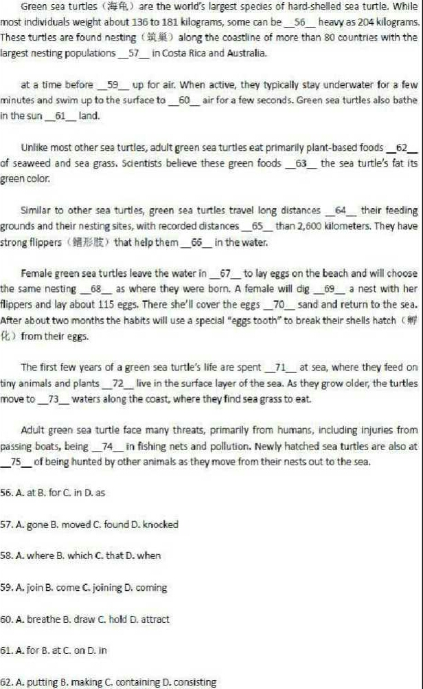
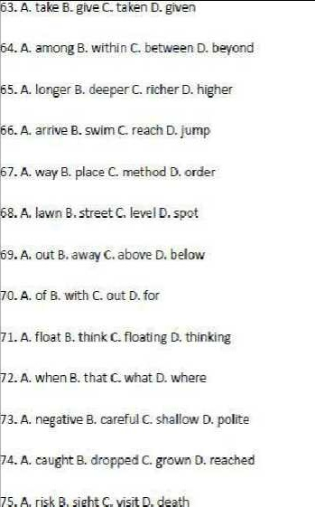
Translation:
76. Both sides show no signs of backing down.

77. Twenty-eight people have been arrested since then and charged with interfering with the pipeline construction.

78. They said their local economies depend on the use of these areas.

79. It may also severely limit activities such as logging, road-building, and hunting.

80. The entire structure cost more than $2.5 million to build at the time.

81. 他在这所学校教多久了？

82. 我希望我们的演出会成功。

83. 春天是游览这个城市的最佳季节。

84. 他们正在打篮球。

85. 他十年前搬到这儿的。
答案：
阅读理解
CABDC DCCBB BDDBD

语法词汇选择
BDADA CACCB CDABB CCDCB BCCDA DCAAB

挑错题
CDAAA CCACC

完形填空
DCADA CDBDA BDDAB CBCAA

翻译
汉译英
81. How long has he been teaching in this school?
82. I hope our performance will be a success.
83. The best season to go round this city is in spring
84. They are playing basketball.
85. He moved here 10 years ago.

